Maps in Dart

Exercise #1

Flutter Developer Bootcamp

# **Purpose**

This Exercise demonstrates how to work with maps and perform operations like calculation of total cost using the values in Dart.

# **Problem**

In the provided Exercise You need to create as follows:

* Define a map petPrices where the keys are pet names (strings) and the values are their corresponding prices (doubles).
* Calculate the total cost by adding up all the values in the petPrices map using the reduce method. The reduce method takes a function that specifies how to combine the elements. In this case, it adds each element to the accumulator (value) starting from the initial value of 0.
* Finally, print the original map petPrices and the total cost with a fixed precision of two decimal places.

**How to Solve**

1. Checkout the Exercise from Git Repo:

git clone -b <user-branch> <repo-URL>

2. Open the root folder inside VS Code

3. Open the root folder in terminal

4. Run the command dart run filename.dart

5. Map Initialization:

* + Initializes a map named petPrices where the keys are pet names (strings) and the values are their corresponding prices (doubles).

6. Calculate Total Cost using reduce:

* + The values property of a map returns an iterable containing all the values in the map.
  + The reduce method is used to apply a function to each element in the iterable to reduce it to a single value.
  + In this case, the function passed to reduce takes two parameters (value and element) and returns their sum. It accumulates the sum of all elements, starting from an initial value of 0.

7. Print Results:

* + The first print statement prints the original map petPrices.
  + The second print statement prints the total cost, formatted with two decimal places using toStringAsFixed(2) toFixed method.

8. Go To File: <specific-file-with-Map-method> à <method-name>, implement your logic.

**You will Achieve**

When you complete this Exercise you will learn the following:

* **Map Initialization:**A Map named petPrices is initialized, where pet names are mapped to their respective prices. This is achieved using the curly braces {} notation.
* **Calculating Total Cost**:The reduce method is applied to the values of the petPrices map to calculate the total cost.reduce is a higher-order function that iterates over the elements of an iterable (in this case, the values of the map) and accumulates a single result. It takes a callback function as an argument, which specifies how the accumulation is done.
* **The callback function passed to reduce takes two parameters:** value (the accumulated result so far) and element (the current element being processed). It returns the sum of value and element, effectively summing up all the prices.
* **Printing Results:**The original map petPrices is printed using print("Pet Prices: $petPrices").
* The total cost is printed using print("Total Cost: \$${totalCost.toStringAsFixed(2)}").
* toStringAsFixed(2) is used to format the total cost with two decimal places.
* **Functions and Methods included:**
* **main():** Entry point of the Dart program.
* **Map:** Data structure used to store key-value pairs.
* **values:** Property of a map that returns an iterable containing all the values.
* **reduce():** Method applied to the iterable to accumulate a single result.
* **toStringAsFixed():** Method used to format a double value with a fixed number of decimal places.
* **print():** Method used to output data to the console.

By running this code, you'll see the pet prices and the total cost printed to the console. This exercise helps in understanding map initialization, higher-order functions like reduce, and formatting output in Dart.

# **Screenshots**

## **Expected output (with MAP)**

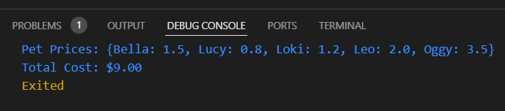

## 

# **How to submit your Exercise**

Push your project back to the same git branch using command:

<command name>

# **Happy Coding!**